The territory of Castiglion Fiorentino offers both the beauty of a natural environment and man-made landscapes that characterize so well the Tuscan setting. Nestled between two prominent valleys, “Val di Chio” and the “Val di Chiana”, this territory bears testimony to impressive land reclamation projects initiated in ancient times, continued by the Medici and completed in the early 19th century. In recent years additional projects have included a system of recreational areas that offer beautiful hiking and bike trails, equestrian routes that follow ancient canals and farms, wooded areas, archaeological sites and wildlife habitat. This extensive trail system extends to an even larger area called the Sentiero della Bonifica that stretches from Arezzo to Chiusi. The Castle of Montecchio, once owned by the historic figure John Hawkwood, adds to the historic richness of the area.
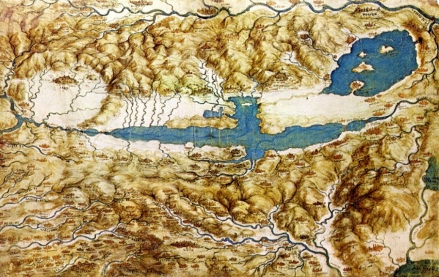
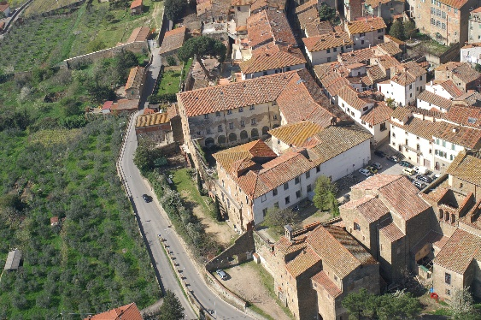

Leonardo’s map for the Val d’ Chiana with C.Fiorentino

The Santa Chiara complex dating back to the 1500’s is a self-contained campus consisting of approximately 5,000 square meters: dormitories for 85 students, classrooms, studios, dining areas, theater and conference room, multi-media studio space, dark room, student lounge, dormitories, faculty offices, café’ and dining room.

